**Ideation Phase**

**Define the Problem Statements**

|  |  |
| --- | --- |
| Date | 19 September 2022 |
| Team ID | NM2023TMID19096 |
| Project Name | Un Covering The Hidden Treasures of Mushroom Kingdom. A classification analysis |
| Maximum Marks | 2 Marks |

**Customer Problem Statement Template:**

Mushrooms have high nutritional value. They are a rich source of protein and fiber and have very low calories and low cholesterol. Days are not far when mushrooms will be a regular alternative to vegetables for many vegetarians. India is having a favorable environmental condition to grow mushrooms. Hence various varieties of mushrooms are grown in different regions of India. However, the per capita consumption of mushroom in India is very less as compared to other countries though mushroom has many health benefits as compared to other regular diets a normal Indian consumes.

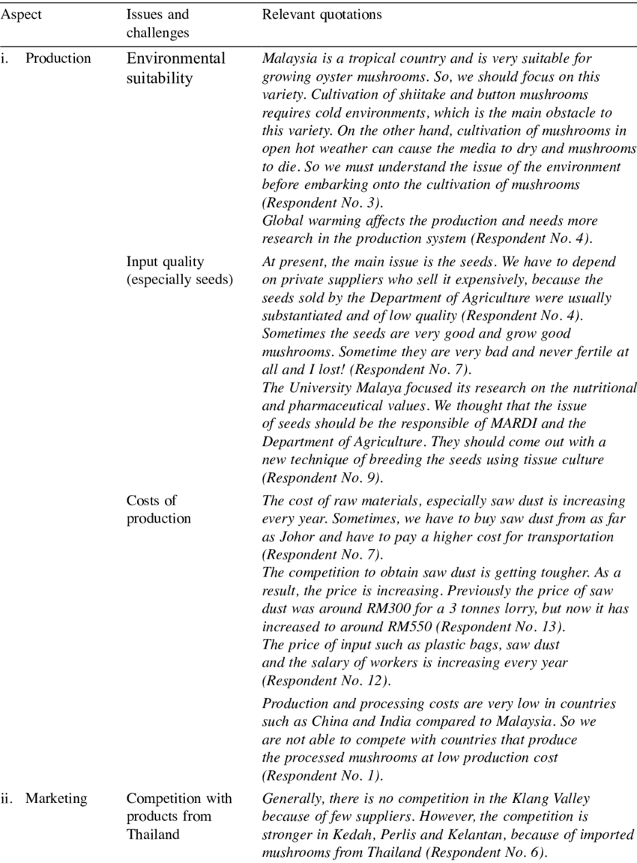

Reference: <https://doi.org/10.1615/IntJMedMushr.v3.i4.50>

